CS 255 System Design Document Template

This template lays out all the different sections that you need to complete for Project Two. Each section has guidance to prompt your thinking. You will need to continually reference the interview transcript as you work to make sure that you are addressing your client’s needs. There is no required length for the final document. Instead the goal is to complete each section based on what your client’s needs are. Remove this note when you are finished, and replace all bracketed text with the relevant information.

UML Diagrams

UML Use Case Diagram

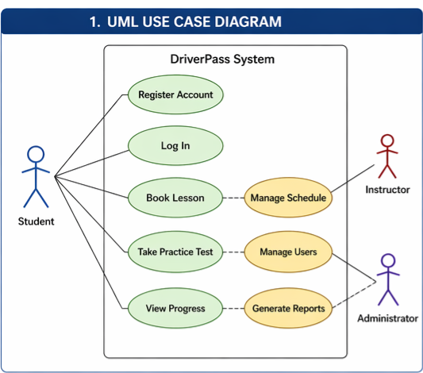

UML Activity Diagrams

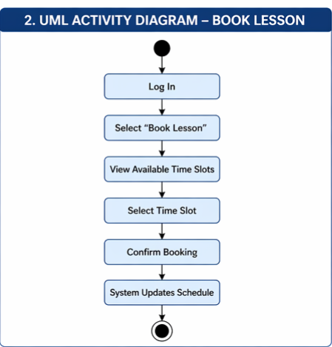

UML Sequence Diagram

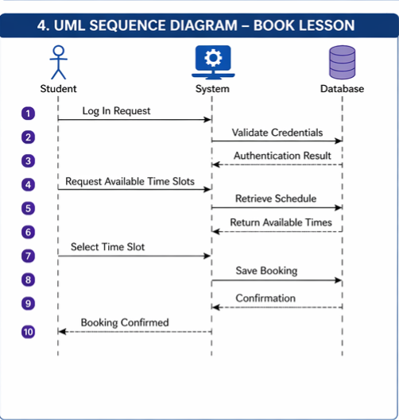

UML Class Diagram



Technical Requirements

The Driver Pass system is designed to be super easy to use by making it fully web based. That means students and staff can log in from any device whether it’s a laptop, tablet, or phone without needing to download anything. As long as they have a browser, they’re good to go.
Behind the scenes, the system uses a secure database to store things like user accounts, lesson schedules, instructor info, and student progress. It’s built on a cloud-based setup, which basically means it can grow as more people start using it and won’t slow down when multiple users are on at the same time.
Security is also a big focus. Users will log in through a secure system with encrypted data, and different roles like students, instructors, and admins will only have access to what they actually need. This helps keep everything organized and protected.
The system also supports real-time updates, so if something changes like a lesson being booked or updated it shows up right away for everyone involved.
As far as building the system goes, it uses standard web technologies like HTML, CSS, and JavaScript for the front end, along with a backend language like Java or C++. It can also connect to outside systems, like DMV updates, using APIs.
Overall, the goal is to keep the system simple to use, secure, and flexible enough to grow with Driver Pass over time.

